# Ma Chiyu and Wu Yuqia’s rebuttal

# Bingxin Huang:

Some classic techniques have been adopted by Wan Mengting's bachelor thesis, thus we only used some other methods to get some new result. Some reduction methods focusing on local information might also be important. The novel is narrated in chronological order. Thus we may try some manifold learning methods in the future.

# Zongchao Mo

How to visualize the results of the program more clearly is really perplexing to us. Maybe we should use some other tool to visualize Matlab's result rather than use matlab's graph directly.

# Xiaowen Fu:

Section 3.3 of our report is the analysis about dimension reduction and novel itself. We itemized several points that are revealed by the figures there. About section 4, we can offer some analysis of more literary significance.

# Jiayi Li:

Section 3.3 of our report is the analysis about dimension reduction and novel itself. We itemized several points that are revealed by the figures there. About section 4, we can offer some analysis of more literary significance.

# Xueyang Quan 1:

This review is to another report which is about Journal to the West西游记 rather than ours.

# Xueyang Quan 2：

Some other methods can be found in Wan Mengting's bachelor thesis, such as PCA. It is worth mentioning that the numerical results of sparse PCA are similar to those of PCA. And in the future we will try some other methods.

**Kot Chun Kit:**

The same as above.

**Yingshu Chen:**

We have added some contents to our conclusion.

**ADELEKE Maradesa & OGEDENGBE Ikeoluwa:**

1. Have added it in the revised version.
2. The aim of section 4 is not to discuss the performance of each sparse principal component but to see who are the main roles of two parts of the novel and base on this we can find the difference between them. And in Wan Mengting's bachelor thesis, we know that this novel mainly consists of two plot lines, so we only discussed the first two sparse principal components in this mini project.
3. Have corrected in the revised version.
4. In NIP format, the title of tables need to written above. We have corrected it. Refer to the following picture.
5. We will improve our written ability in the future.

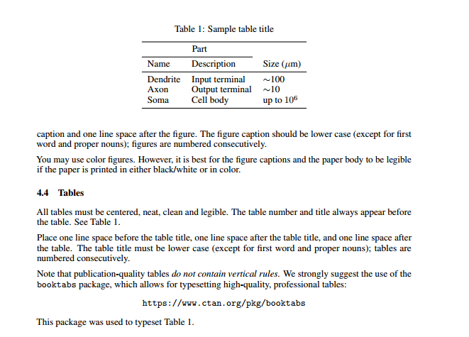

**Cheng Haoyi:**

The same as above.